**Weekly Assessment**

**Scala Programming**

Name: M Jeyapathy

USN: 22BTRAD016

In this **assignment**, students will create a custom type class in Scala and use it in an application. The type class should define a set of behaviours that can be applied to different types, such as numeric types, strings, or custom data types. The student should implement the type class using implicit conversions and demonstrate how it can be used in an application. The student should also write tests to ensure that the type class works correctly.

Program with output:

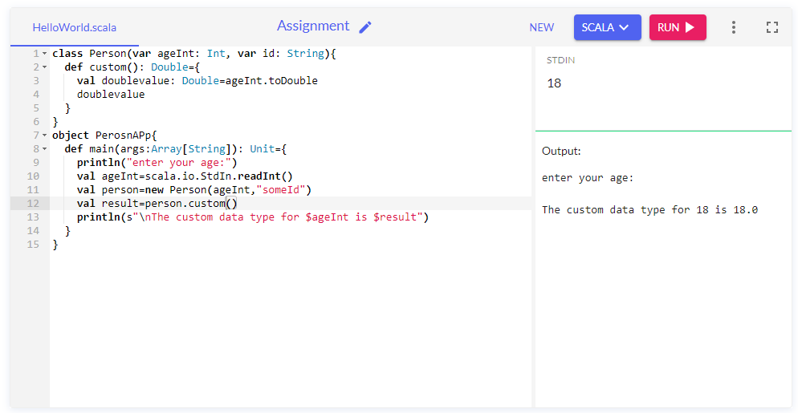

Git hub Link: https://github.com/Jeyapathy/Scala-Programming